# 

**MiniProject-1**

DEPARTMENT OF COMPUTER APPLICATION

BCA-2024

SEMESTER-3

FRONT END WEB DEVELOPMENT

Mentor Name : Veera Raghav K

Done by: Muhammed Faiz C K

Reg No: 2411021240042

Mentor’s Signature:

## Introduction about Using Technologies

This project demonstrates how to create a simple Facebook-like login page using HTML and CSS. HTML (HyperText Markup Language) is used to structure the content of the web page, while CSS (Cascading Style Sheets) is used to style and design the elements, such as colors, borders, alignment, and hover effects. The page includes form elements like input fields, buttons, and hyperlinks.

## Input Code & Explanation

Below is the HTML and CSS code used for creating the Facebook login page:

<html>  
 <head>  
 <link rel="icon" href="./facebook.png">  
 <title>Facebook Login Page</title>  
 <style>  
 h1{  
 text-align: center;  
 color: #1877F2;  
 margin-top: 40px;  
 }  
 div{  
 border-radius: 6px;  
 border: 1px solid black;  
 width: 400px;  
 height: 280px;  
 margin-left: 175px;  
 border: 1px solid #ccc;  
 box-shadow: 6px 6px 6px #ccc;  
 }  
 p{  
 text-align: center;   
 }  
 input{  
 border-radius: 6px;  
 margin-left: 20px;  
 width: 360px;  
 height: 45px;  
 border: 1px solid #ccc;  
 }  
 ::placeholder{  
 color: #ccc;  
 padding-left: 10px;  
 }  
 .i1{  
 margin-top: 12px;  
 }  
 button{  
 margin-top: 15px;  
 margin-left:20px ;  
 width: 360px;  
 height: 45px;  
 background-color: #1877F2;  
 color: white;  
 border-radius: 6px;  
 border: none;  
 }  
 button:hover{  
 background-color: #145DBF;  
 }  
 #para{  
 color: #1877F2;  
 }  
 </style>  
 </head>  
 <body>  
 <h1>facebook</h1>  
 <div>  
 <p>Log in to Facebook</p>  
 <form action="">  
 <input type="text" placeholder="Email address or phone number">  
 <input class="i1" type="password" placeholder="Password">  
 <button><a href="https://www.facebook.com/login/device-based/regular/login/?login_attempt=1&lwv=120&lwc=1348028">Log in</a></button>  
 <p id="para"><a href="https://www.facebook.com/login/identify/?ctx=recover&ars=facebook_login&from_login_screen=0">Forgotten account?</a>   
 <a href="https://www.facebook.com/r.php?locale=en_GB&display=page">Sign up for Facebook</a></p>  
 </form>  
 </div>  
 </body>  
</html>

Explanation:  
- The <head> section contains the title, favicon, and CSS styling.  
- The <style> block defines styles such as text alignment, colors, borders, and hover effects.  
- The <body> contains a heading (facebook), a styled div, and a form with input fields.  
- Input fields accept email/phone number and password.  
- A button styled with CSS allows users to log in, linked to Facebook’s login page.  
- Additional links are provided for forgotten accounts and new sign-ups.

## The Tags used here

<form> : The <form> tag is used to create an HTML form for user input. It acts as a container for input fields, buttons, and other elements that collect user data.

<input> : The <input> tag is used to create interactive fields where users can enter data, such as text, passwords, or email addresses. It is essential for login forms.

<div> : The <div> tag is a container element used to group and organize other HTML elements. In this project, it helps structure the layout of the login box.

<h1> : The <h1> tag represents the main heading of a webpage. It is used here to display the 'facebook' title at the top of the page with large, bold text.

<link> : The <link> tag is used to link external resources to the HTML document, such as CSS files or icons. In this project, it is used to set the favicon (browser tab icon).

## Output Code & Screenshots

The output is a simple Facebook login page replica with input fields for email/phone and password, along with login, forgotten account, and sign-up options. Below is a screenshot of the output:

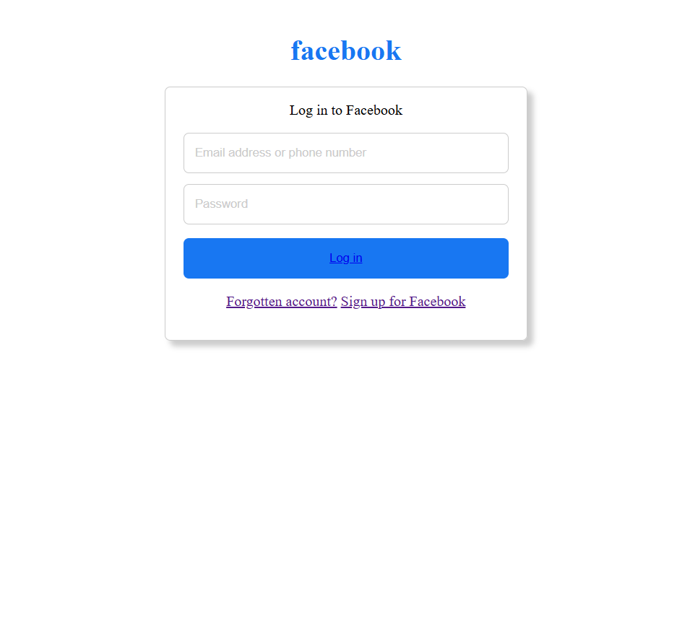

## Conclusion

This project demonstrates how to design a Facebook-style login page using only HTML and CSS. It provides hands-on practice with HTML form elements, styling with CSS, and structuring a user interface. The project shows the importance of combining design and functionality in web development.